**Objective 4:**

* Print all prime no between 100 and 300.
* Print all Armstrong no between 100 and 9999.
* Print all the pattern:

1

2 1

4 2 1

8 4 2 1

16 8 4 2 1

32 16 8 4 2

*

***

*****

********

*****

***

*

Answer:

1.

Code:

upper=eval(input("enter the upper limit"))

lower=eval(input("enter the lowe4 llimit"))

print("prime number are :")

for i in range(upper,lower+1):

temp=0

for j in range(2,i//2+1):

if(i%j==0):

temp=1

if(temp==0):

print(i)

output :

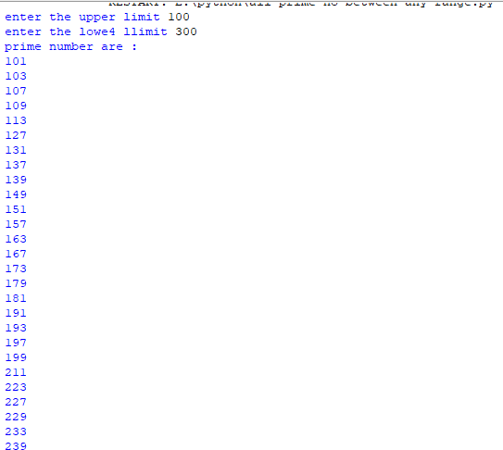

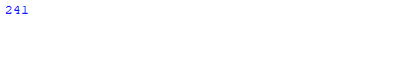

2.

Code:

low=eval(input("enter the lower limit"))

high=eval(input("enter the upper limit"))

print("palindrome no in range",low,"and ",high,"is :")

for i in range(low , high+1) :

x = i

count= 0

while (x != 0) :

x = x // 10

count= count + 1

sum = 0

x = i

while (x != 0) :

digit = x % 10

sum = sum + pow(digit, count)

x = x //10

if (sum == i) :

print(sum ," "),

output :

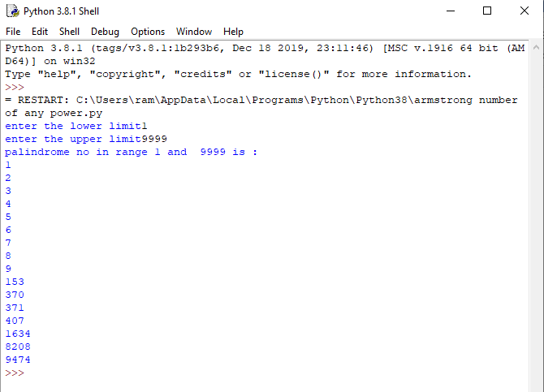

3.

Code:

rows = int(input("Enter the number of rows:" ))

k = 0

for i in range(1, rows + 1):

for j in range (1, (rows - i) + 1):

print(end = " ")

while k != (2 * i - 1):

print("*", end = "")

k = k + 1

k = 0

print()

k = 2

m = 1

for i in range(1, rows):

for j in range (1, k):

print(end = " ")

k = k + 1

while m <= (2 * (rows - i) - 1):

print("*", end = "")

m = m + 1

m = 1

print()

output:

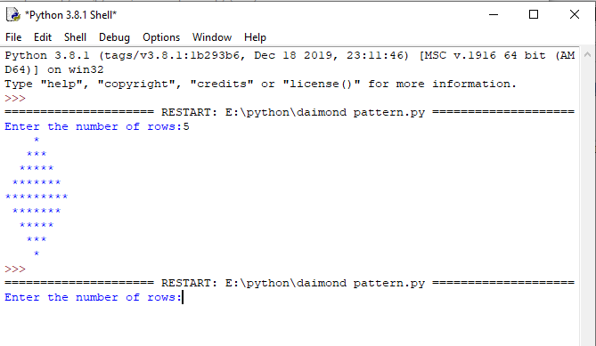

4.

Code:

print(" Number Pattern")

lastNumber = eval(input())

for i in range(1, lastNumber):

for j in range(-1+i, -1, -1):

print(format(2**j, "8d"), end=' ')

print("")

output :

